Name
Tutor
Institution
Date
REAL ESTATE INVESTMENT
INTRODUCTION
An analysis conducted in Miami prompted the purchase of a LoopNet. Product, Villa La Pinta apartments. This fiscal decision was based from the value of investments and also the growing demand of apartments in Miami. Villa La Pinta is a lucrative idea for investment because first-off it is convenient. It is close to the city’s social amenities thus it will attract prospective buyers; the working class. Annual projection alone is $3,679,200 and $1 million more by the eight of the year once half the apartment has been sold off. This is an analytical projection based on the fact that Miami apartments tend to appreciate by up to 5% due to increased demand. Investing in Miami, Florida will be a fast rate of return on investment as well as a spontaneous surplus.

MARKET RESEARCH
According to Department of Number article, from the year 2015 statistics show that apartments in Miami Florida appreciate in demand from an average of 5.87% to 10.22%. This shows a 4.35% rise within three years. It also indicates that there is a rise in vacancy rates from – 0.85% to -1.88%. The rental vacancy rate simply refers to the fraction of homes not occupied. This shows that with the growing trends it is most unlikely to stay one month without filling al the rental units. From the initial investments, we have a more likelihood of a tremendous rise in investments. According to the city data article, Miami has an estimated medium household income of $34,901 in 2016 from $23,483 recorded in 2000. Five and more housing unit that same financial year recorded revenues of $433,645 that made the medium gross rent for 2016 to be $ 1,063. It estimated that Miami urban area has is home to 5.5 million people according to World Population article review.
¹²https://www.deptofnumbers.com/rent/florida/miami/
¹⁹http://www.city-data.com/city/Miami-Florida.html
²¹http://worldpopulationreview.com/us-cities/miami-population/

According to the statistics given, we find out that investing in Miami Florida there is a more likelihood of getting an increase of return of investments and a surplus. Not only is there a demand for housing but also the residence has an average sustainable income to live in modern apartments. We also get to find out Miami hosts many people in the urban area that will be our major customer niche. Many people want to be close to the city to experience the urban lifestyle available in the city. This person are mainly composed of the working class and those with families. Since our units comprise with one bedroom, it will help us capture the working class as our primary customer target.
Cash Return and Projections
Cash on cash return = annual before-tax cash flow
Total Cash invested
Annual before-tax cash flow = average rental income * number of units * number of months per year
=$1275* 28*12
=428400
Total cash invested =total purchase – initial investments
=$3975000 - $2500000
= 1475000
= 428400
1475000
=0.29044067796610169491525423728814
% cash on cash return = cash on cash return *1000
i.e. % cash on cash return = 0.29044067796610169491525423728814* 100
=29.044067796610169491525423728814
~29%
Below is a table for illustrations
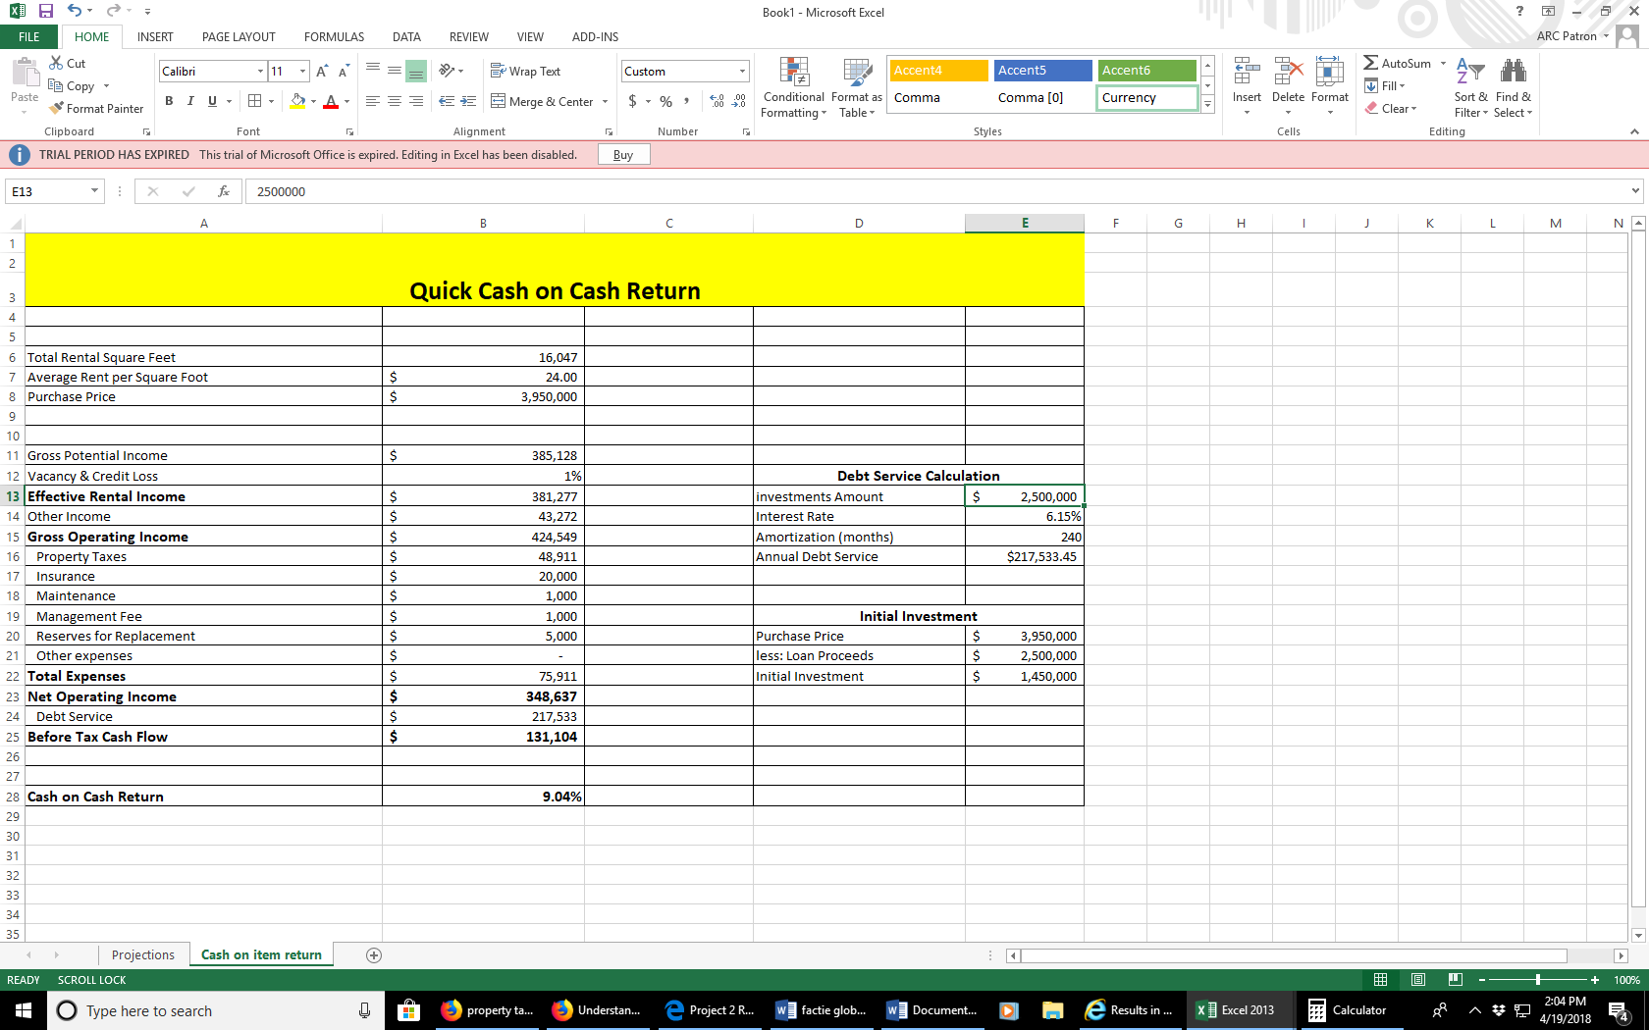
PROJECTIONS
According to Integra Realty Resources (IRR)(2016), apartments in Miami appreciate by 17% (p.4)( Integra Realty Resources,2016).
https://www.google.com/url?sa=t&rct=j&q=&esrc=s&source=web&cd=10&ved=0ahUKEwiP9uqancbaAhUtMuwKHaFkCQIQFgisATAJ&url=http%3A%2F%2Fwww.miamidda.com%2FMiamiDDA%2Fmedia%2FMiamiDDA%2FDocuments%2FIRR-Miami-DDA-Residential-Study-Q4-2015.pdf&usg=AOvVaw3YTqktSQCHEY7dZXKrTcrI
We get to find out there is a growing demand of apartments in Miami that increases. Due to this fact by the eighth year, the property would have approximately appreciated by 17%. We are projecting a net annual income of $3,679,200 by the eighth year and $4650750 a sell of the apartment by then. The table below illustrates that.
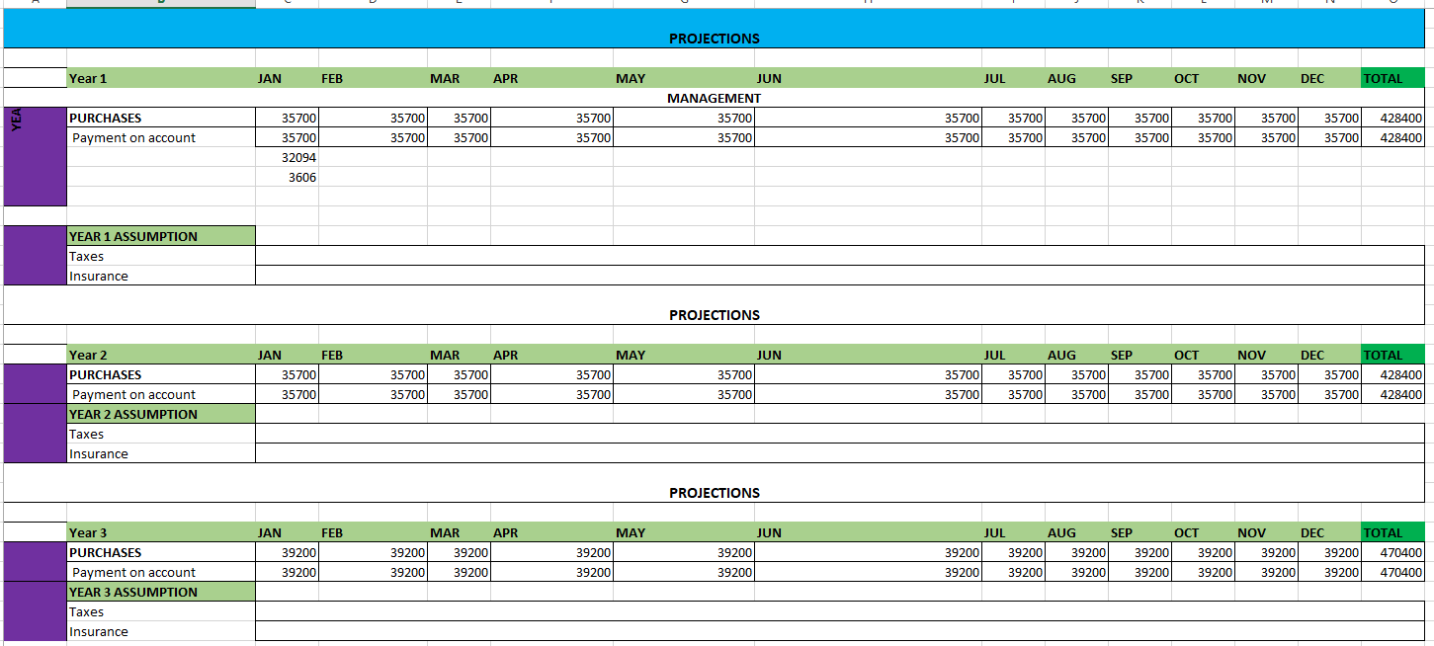

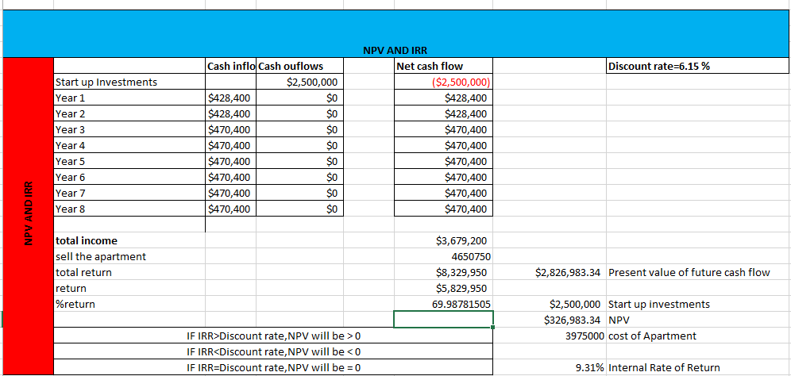
The studio will act as a surplus and other income.
By the third year, we will raise the monthly rent by $125 per unit to make it $1400 so that our monthly income would be $39200.

